- 

Information Management System Design Practice
Course Design Report

Course Name Information Management System
Student Name Sabet Abderrahmane
Student Class 21Iq
Student Number 2111551211

December 2024

Contents
Contents
Contents 4
1.System planning 1
1.1 Problem description 1
1.2 Feasibility analysis 1
2. System analysis 2
2.1 Functional definition 2
2.2 Functional structure 8
3. System design 9
3.1 System module partition 10
3.2 Database design 11
3.3 Functional module design 12
4. Summary 13
References 14
Appendix 15
Course design report score sheet 48

1.System planning

1.1 Problem description
Hotels play a critical role in offering hospitality services that require efficient management of operations such as dining, reservations, and staff coordination. Traditional paper-based or fragmented digital systems often lead to inefficiencies, such as:
- Delays in Service: Mismanagement of dish preparation schedules or table availability can result in long wait times.
- Reduced Customer Satisfaction: Lack of real-time updates on reservations or insufficient menu details leads to guest dissatisfaction.
- Operational Losses: Overlapping staff schedules and inventory mismanagement cause unnecessary expenditures.
Example Scenarios:
- Busy Lunch Hours: During peak dining times, a table meant for reservation remains occupied because the staff lacks real-time updates.
- Menu Mismanagement: A customer orders a dish that is unavailable due to inventory exhaustion, but the kitchen staff was unaware.
- Staff Scheduling Overlaps: Multiple waiters are scheduled for the same shift, leaving other times understaffed.
The Hotel Dish Management System addresses these challenges by integrating real-time data management and automation.

1.2 Feasibility analysis
Technical Feasibility
- Developed in C# with WPF, ensuring compatibility with Windows environments.
- Uses SQLite for a lightweight database solution, eliminating the need for complex server setups.
- Integrated tools like LiveCharts provide advanced data visualization features.
Economic Feasibility
- Cost-effective: Relies on open-source libraries and tools like SQLite and Visual Studio Community Edition.
- Reduces operational costs by automating repetitive tasks, such as table status updates and staff scheduling.
Operational Feasibility
- Ease of Adoption: Intuitive UI and modular design reduce the learning curve for hotel staff.
- Efficiency: Real-time synchronization of data across modules improves decision-making and customer satisfaction.
- Scalability: Additional features, such as mobile app integration or cloud-based storage, can be easily added.

- System analysis

Functional definition
The Hotel Dish Management System is tailored to meet the operational needs of a high-end hotel. It focuses on automating repetitive tasks, enhancing accuracy, and providing insightful data visualizations. Below is a detailed breakdown of each module's functionality:
Dish Management Module
This module enables efficient management of the hotel\u2019s menu by providing the following functionalities:
- Add New Dishes: Staff can input dish details such as name, category, price, and description, and upload an image.
- Edit Existing Dishes: Allows modifications to dish details to keep the menu updated.
- Delete Dishes: Removes outdated or unavailable dishes from the menu.
- Query Dishes: Staff can search dishes by criteria such as price, category, or special attributes (e.g., vegan, gluten-free).
Example Use Case:
A chef queries all "vegan dishes" in the menu to plan a special menu for an upcoming vegan dinner event.
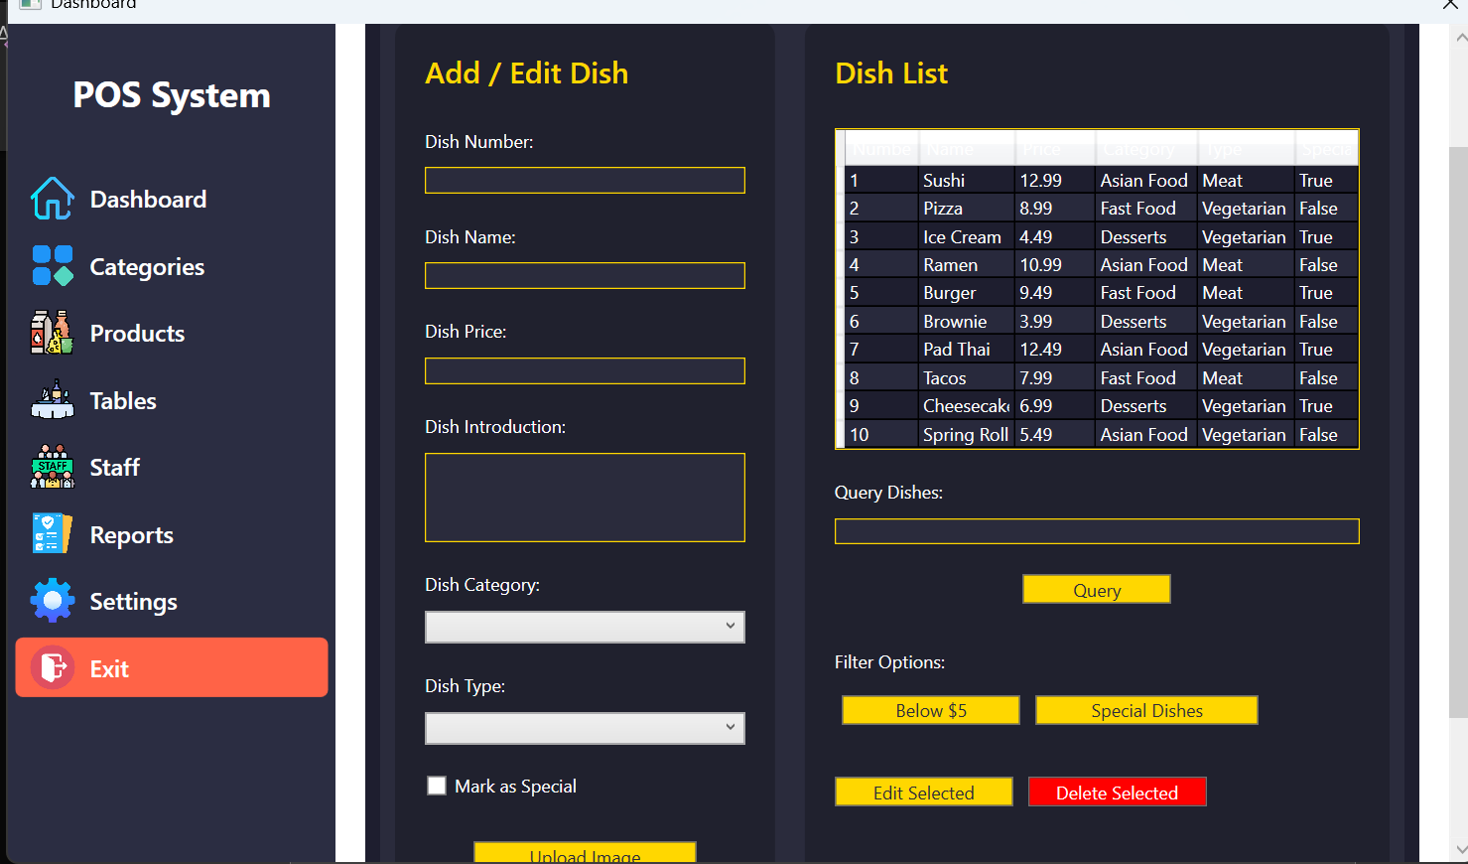
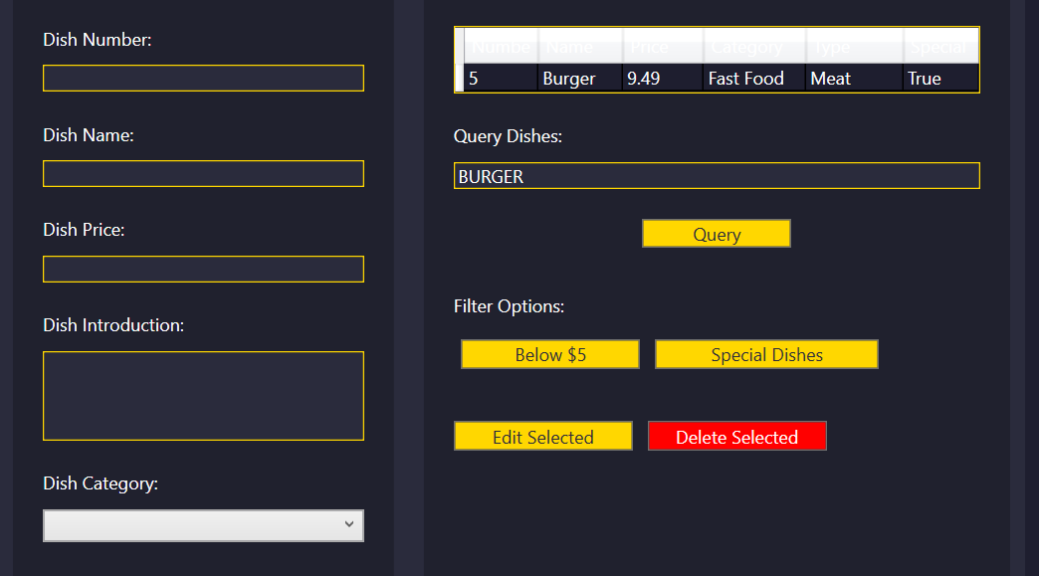

Table Management Module
This module streamlines table reservations and real-time status updates, offering the following functionalities:
- Real-Time Table Tracking: Tables are marked as Available, Reserved, or Occupied.
- Add Reservations: Enables the reception desk to book tables with customer details, including time and special requests.
- Modify Reservations: Updates existing reservations with changes in time or table number.
- Cancel Reservations: Deletes reservation records for no-shows or cancellations.
Example Use Case:
During peak hours, a receptionist checks available tables and books one for a walk-in customer.
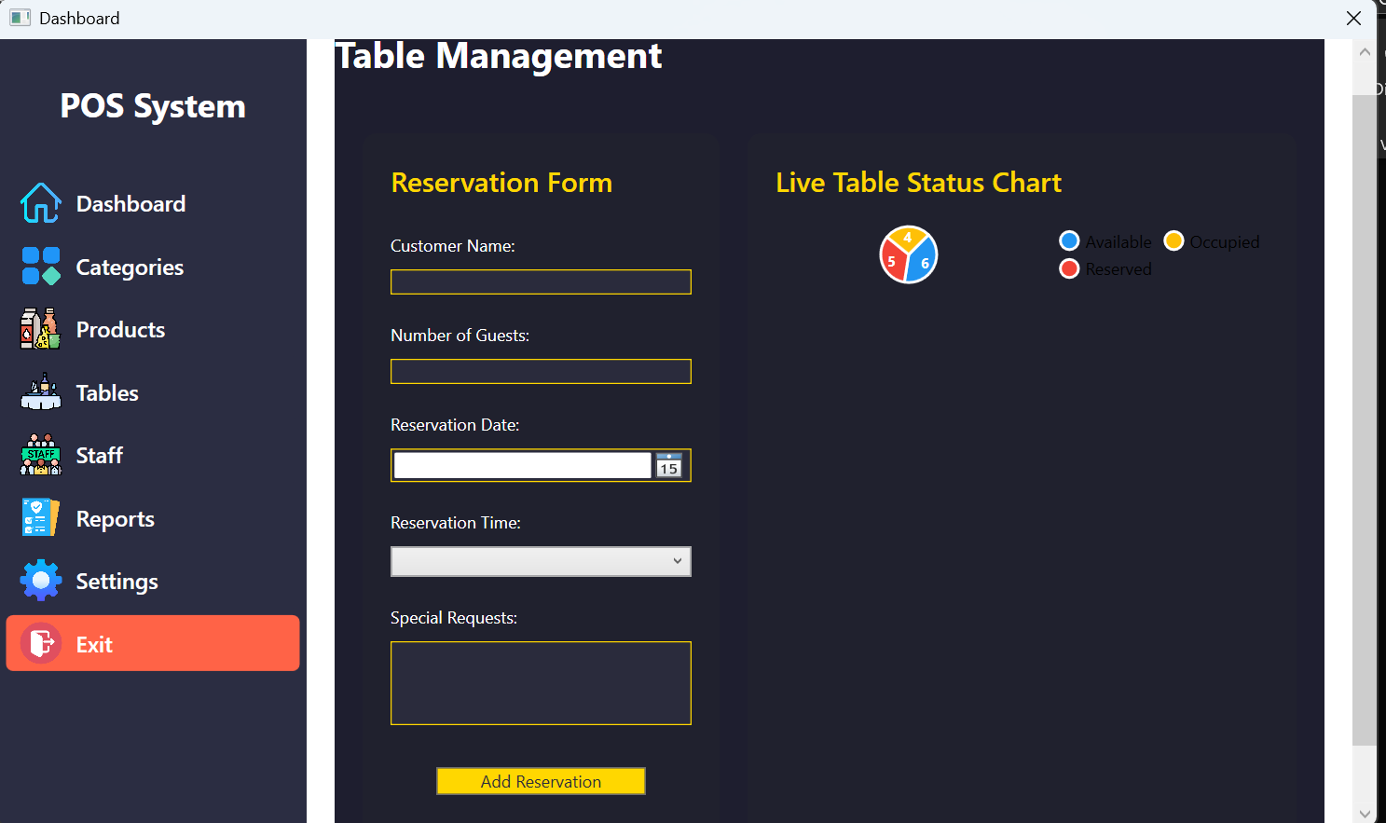

Staff Management Module
The staff module centralizes employee records and role-based management. Functionalities include:
- Add Staff Profiles: Captures employee details, including role, contact, and schedule.
- Edit Staff Information: Updates roles or contact information for staff members.
- Remove Staff Records: Deletes profiles of employees who have left the organization.
- Role-Based Filters: Enables staff to filter employees by their roles, such as chefs or cleaners.
- Live Visualization: Pie charts summarize the distribution of staff roles.
Example Use Case:
A manager views a pie chart showing staff role distribution to ensure adequate staffing during the holiday season.
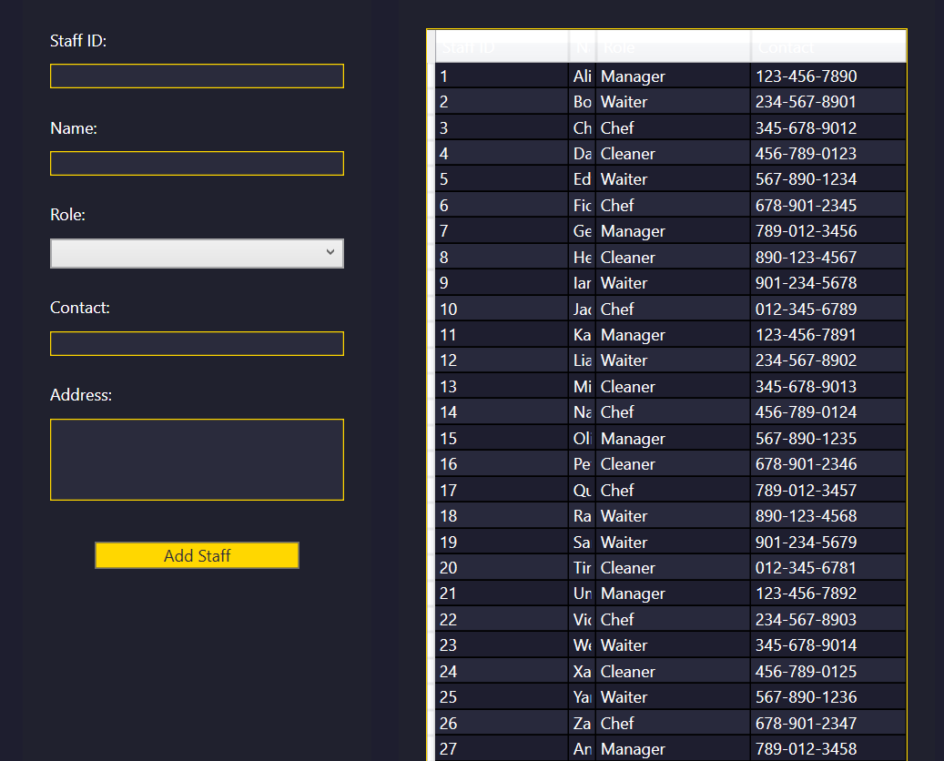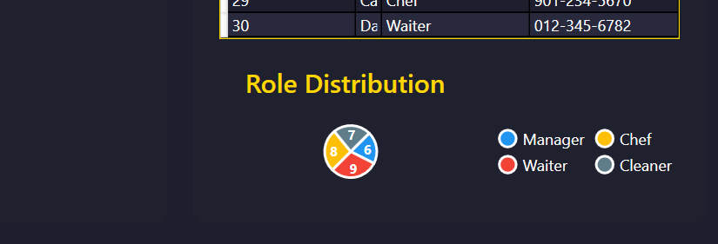
Dashboard Module
The dashboard provides a real-time summary of hotel operations through interactive charts and graphs. Features include:
- Table Occupancy: Displays the current availability of tables.
- Dish Insights: Highlights best-selling dishes and low-performing menu items.
- Staff Summary: Visualizes the role distribution and availability of employees.
Example Use Case:
The hotel manager uses the dashboard to identify the most ordered dishes and underutilized tables to optimize services.
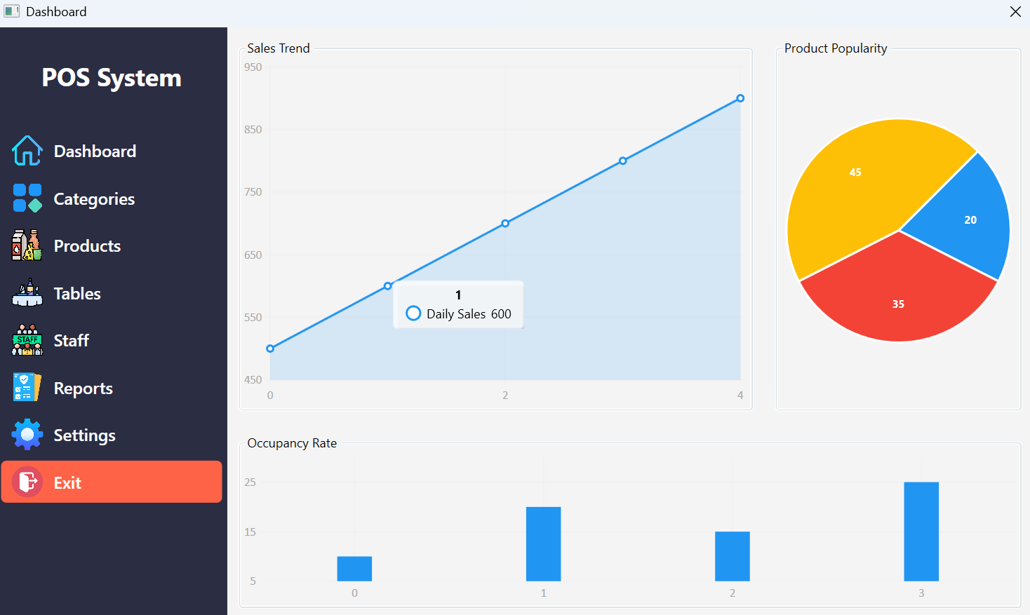
Categories Module
This module organizes dishes into intuitive categories for easy navigation and management:
- Define Categories: Group dishes into categories (e.g., appetizers, desserts) and subcategories (e.g., Asian cuisine -> Thai, Chinese).
- Assign Dishes: Link dishes to their respective categories during data entry.
- Modify Categories: Edit or delete categories to keep them relevant to the menu.
Example Use Case:
The marketing team adds a "Seasonal Specials" category to highlight dishes for a summer-themed event.

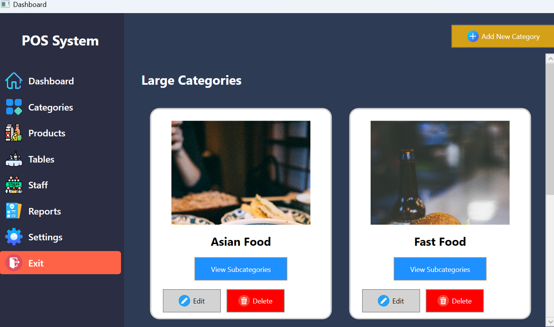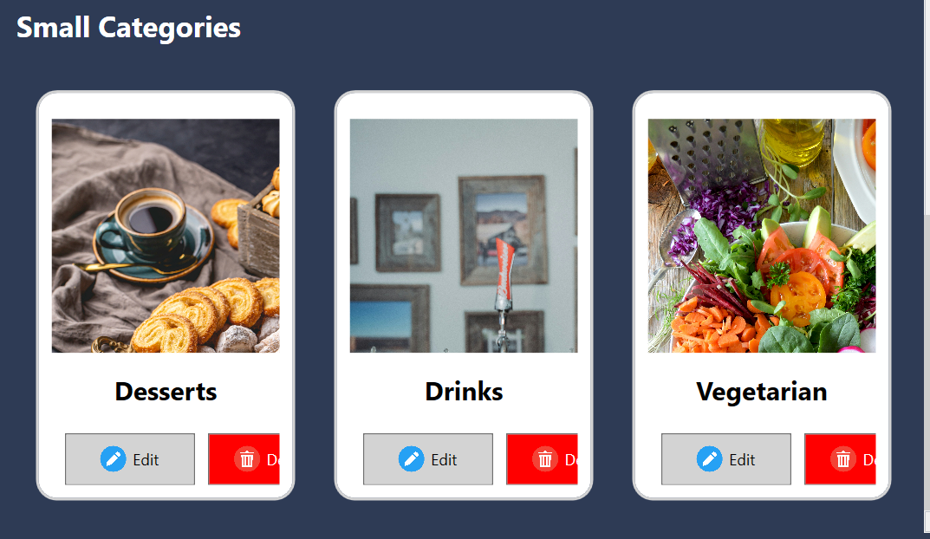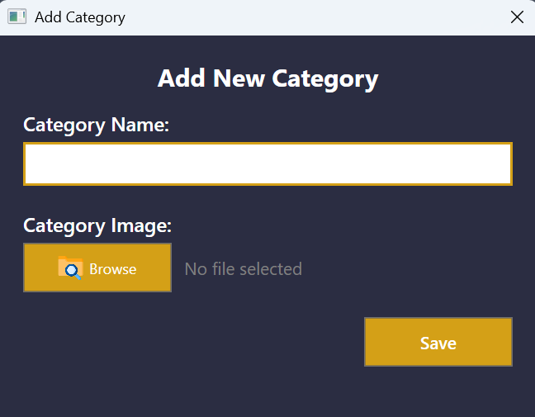

Functional structure
To better understand how the system components interact, consider the following breakdown and relationships among modules:
Module Relationships
- Dashboard as a Central Hub:
  - Aggregates data from all modules (Dishes, Tables, Staff, Categories).
  - Updates dynamically when any module is modified.
- Dishes and Categories Interaction:
  - Every dish must belong to a category.
  - Updating a category affects all associated dishes.
- Tables and Reservations:
  - Each table has a status (Available, Reserved, Occupied).
  - Reservations directly update table statuses.
- Staff and Role-Based Management:
Staff data feeds into the dashboard for role distribution analysis

Detailed User Stories
Here are additional user stories to demonstrate real-world scenarios where the system adds value:
- Hotel Receptionist:
  - As a receptionist, I need to view real-time table availability to avoid double booking and ensure seamless service.
- Hotel Manager:
  - As a manager, I need to analyze staff availability and adjust roles to cover peak hours effectively.
- Chef:
  - As a chef, I need a categorized view of dishes to plan inventory and identify popular menu items.
- Marketing Team:
  - As part of the marketing team, I want to create seasonal categories to promote new dishes and attract more guests.

Detailed Functional Requirements
Dish Management
- Input Validation: Ensure that all required fields (e.g., dish name, price) are filled during entry.
- Batch Updates: Allow users to update multiple dishes at once (e.g., apply a price hike to an entire category).
Table Management
- Reservation Conflicts: Automatically prevent overlapping bookings for the same table.
- Reservation Alerts: Notify staff about upcoming reservations 15 minutes before the scheduled time.
Staff Management
- Performance Tracking: Track the performance of each role (e.g., average order delivery time for waiters).
- Role Assignment: Allow role reassignments (e.g., promote a cleaner to a waiter).
Dashboard Customization
- Custom Reports: Enable users to generate reports based on filters (e.g., "most reserved tables during weekends").

- System design

3.1 System module partition
The system is divided into five primary modules, each responsible for specific hotel operations. Below is a detailed description of each module:
Dashboard Module
- Purpose: Serve as the central hub for monitoring real-time hotel operations.
- Features:
  - Displays charts for dish performance, table occupancy, and staff roles.
  - Aggregates data from all other modules and provides actionable insights.
  - Updates dynamically when new data is added or modified.
- Interaction with Other Modules:
  - Pulls dish data from the Dishes module for performance metrics.
  - Retrieves table statuses from the Tables module to show occupancy rates.
  - Extracts staff distribution data from the Staff module for role analysis.
Dishes Module
- Purpose: Manage and organize dish information for the hotel menu.
- Features:
  - Add, edit, delete, and query dishes.
  - Group dishes into categories and subcategories.
  - Filter dishes by price, type, or availability.
- Interaction with Other Modules:
  - Links with the Categories module to organize dishes.
  - Shares dish data with the Dashboard for performance visualization.
Tables Module
- Purpose: Handle reservations and real-time table management.
- Features:
  - Maintain the status of tables (Available, Reserved, Occupied).
  - Enable staff to book tables for guests with specific time slots and notes.
  - Provide filters for table availability and reservation conflicts.
- Interaction with Other Modules:
  - Updates Dashboard metrics for table occupancy.
  - Records reservation details in the database.
Staff Module
- Purpose: Centralize staff information and provide role-based insights.
- Features:
  - Add, edit, and remove staff profiles.
  - Filter staff by roles and display distribution in charts.
  - Allow shifts and role assignments.
- Interaction with Other Modules:
  - Supplies role distribution data to the Dashboard.
  - Tracks staff availability for table management and dish preparation.
Categories Module
- Purpose: Organize dishes into meaningful categories for streamlined management.
- Features:
  - Create and manage categories and subcategories.
  - Link dishes to their respective categories.
  - Enable filtering and browsing of dishes by category.
- Interaction with Other Modules:
  - Facilitates dish grouping in the Dishes module.
  - Supports dynamic updates for category-based filters in the Dashboard.

3.2 Database design
The system uses SQLite as its database engine, ensuring a lightweight and efficient solution. Below is the detailed schema:
Database Tables
1. Dishes Table
Column Name | Data Type | Description
DishID | INTEGER | Unique identifier for each dish
Name | TEXT | Name of the dish
Price | REAL | Price of the dish
CategoryID | INTEGER | Links to the Categories table
Type | TEXT | e.g., "Vegan", "Meat"
Description | TEXT | Description of the dish
2. Tables Table
Column Name | Data Type | Description
TableID | INTEGER | Unique identifier for each table
Status | TEXT | "Available", "Reserved", "Occupied"
ReservationTime | TEXT | Time of the reservation
GuestName | TEXT | Name of the guest
3. Staff Table
Column Name | Data Type | Description
StaffID | INTEGER | Unique identifier for each staff
Name | TEXT | Name of the staff member
Role | TEXT | e.g., "Chef", "Waiter"
Contact | TEXT | Contact information
4. Categories Table
Column Name | Data Type | Description
CategoryID | INTEGER | Unique identifier for each category
Name | TEXT | Name of the category

Sample Queries
- Retrieve All Vegan Dishes:

SELECT Name, Price FROM Dishes WHERE Type = 'Vegan';
- Find Reserved Tables:

SELECT TableID, GuestName FROM Tables WHERE Status = 'Reserved';
- Get Staff Roles Distribution:

SELECT Role, COUNT(*) as RoleCount FROM Staff GROUP BY Role;

3.3 Functional module design
Below is a detailed design of key functional modules:
- Add Dish
Flowchart:
- User enters dish details in the form.
- System validates the input fields.
- Data is stored in the SQLite database.
- Dish is added to the list and the dashboard updates.
Pseudocode:
IF input_fields_are_valid:
INSERT INTO Dishes (Name, Price, CategoryID, Type, Description)
DISPLAY "Dish added successfully"
ELSE:
DISPLAY "Please fill all required fields"

- Book Table
Flowchart:
- Receptionist selects an available table.
- Enters reservation details (Guest Name, Time).
- System checks for conflicts.
- Table status is updated to "Reserved".
Pseudocode:
IF TableID IS Available:
UPDATE Tables SET Status = 'Reserved', GuestName = input_name
DISPLAY "Table reserved successfully"
ELSE:
DISPLAY "Table is not available"

- Summary

The Hotel Dish Management System provides a comprehensive solution to the challenges faced by hotel operations. By integrating modules for dish management, table reservations, staff coordination, and data visualization, the system ensures enhanced efficiency and guest satisfaction. The lightweight architecture and use of SQLite make it a cost-effective and scalable solution for hotels of all sizes.
Key achievements of the system include:
- Operational Streamlining: Automated workflows reduce manual errors and save time. For example, real-time updates on table statuses eliminate double bookings and enhance reservation efficiency.
- Data Insights: The dashboard offers actionable insights through live charts, helping management make informed decisions. Metrics such as dish performance and staff availability are easily accessible.
- User-Centric Design: Intuitive interfaces ensure that staff, from receptionists to chefs, can easily adopt the system. Filters and query options simplify tasks like finding specific dishes or monitoring table reservations.
Future enhancements could include:
- Integration with mobile apps for remote access to reservation systems.
- Advanced analytics to predict customer preferences based on historical data.
- Cloud-based implementation for multi-branch hotels to centralize operations.
The system’s design prioritizes flexibility and scalability, ensuring that it can adapt to evolving hotel management needs while maintaining its core functionality of delivering exceptional service and operational efficiency.

References
- Microsoft Documentation: Windows Presentation Foundation (WPF) Overview.
- Official C# Programming Guide, Microsoft Learn.
- SQLite Documentation for lightweight database solutions.

Appendix
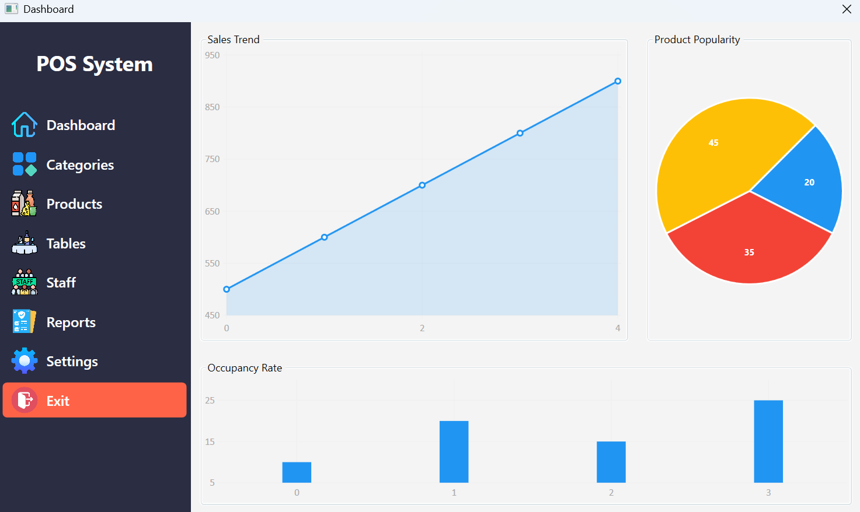

Dashboard xaml
```
<Window x:Class="HotelDishManagement.Dashboard"
xmlns="http://schemas.microsoft.com/winfx/2006/xaml/presentation"
xmlns:x="http://schemas.microsoft.com/winfx/2006/xaml"
Title="Dashboard" Height="600" Width="1000" WindowStartupLocation="CenterScreen" ResizeMode="NoResize">
<Grid>
<!-- Main Layout -->
<Grid.ColumnDefinitions>
<ColumnDefinition Width="220"/>
<!-- Sidebar -->
<ColumnDefinition Width="*"/>
<!-- Content Area -->
</Grid.ColumnDefinitions>

<!-- Sidebar -->
<StackPanel Background="#2B2D42" VerticalAlignment="Stretch" Grid.Column="0">
<!-- Application Title -->
<TextBlock Text="POS System" FontSize="24" FontWeight="Bold" Foreground="White" Margin="20,30,20,30" HorizontalAlignment="Center" />

<!-- Sidebar Buttons -->
<Button Style="{StaticResource SidebarButton}" Content="Dashboard" Tag="/HotelDishManagement;component/Assets/dashboard.png" Click="NavigatePage" />
<Button Style="{StaticResource SidebarButton}" Content="Categories" Tag="/HotelDishManagement;component/Assets/categories.png" Click="NavigatePage" />
<Button Style="{StaticResource SidebarButton}" Content="Products" Tag="/HotelDishManagement;component/Assets/products.png" Click="NavigatePage" />
<Button Style="{StaticResource SidebarButton}" Content="Tables" Tag="/HotelDishManagement;component/Assets/tables.png" Click="NavigatePage" />
<Button Style="{StaticResource SidebarButton}" Content="Staff" Tag="/HotelDishManagement;component/Assets/staff.png" Click="NavigatePage" />
<Button Style="{StaticResource SidebarButton}" Content="Reports" Tag="/HotelDishManagement;component/Assets/reports.png" Click="NavigatePage" />
<Button Style="{StaticResource SidebarButton}" Content="Settings" Tag="/HotelDishManagement;component/Assets/settings.png" Click="NavigatePage" />

<!-- Exit Button -->
<Button Style="{StaticResource SidebarExitButton}" Content="Exit" Tag="/HotelDishManagement;component/Assets/exit.png" Click="ExitApplication" />
</StackPanel>

<!-- Content Frame -->
<Frame Name="ContentFrame" Grid.Column="1" NavigationUIVisibility="Hidden" />
</Grid>
</Window>
Dashboard backend
```
using System.Configuration;
using System.Windows;
using System.Windows.Controls;

namespace HotelDishManagement
{
public partial class Dashboard : Window
{
public Dashboard()
{
InitializeComponent();

// Set default page to Dashboard
ContentFrame.Navigate(new DashboardPage());
}

// Method to handle button navigation
private void NavigatePage(object sender, RoutedEventArgs e)
{
var button = sender as Button;

switch (button.Content.ToString())
{
case "Dashboard":
ContentFrame.Navigate(new DashboardPage());
break;
case "Categories":
ContentFrame.Navigate(new CategoriesPage());
break;
case "Products":
ContentFrame.Navigate(new ProductsPage());
break;
case "Tables":
ContentFrame.Navigate(new TablesPage());
break;
case "Staff":
ContentFrame.Navigate(new StaffPage());
break;
case "Reports":
ContentFrame.Navigate(new ReportsPage());
break;
case "Settings":
ContentFrame.Navigate(new SettingsPage());
break;
}
}

// Method to handle the Exit button
private void ExitApplication(object sender, RoutedEventArgs e)
{
Application.Current.Shutdown();
}
}
}
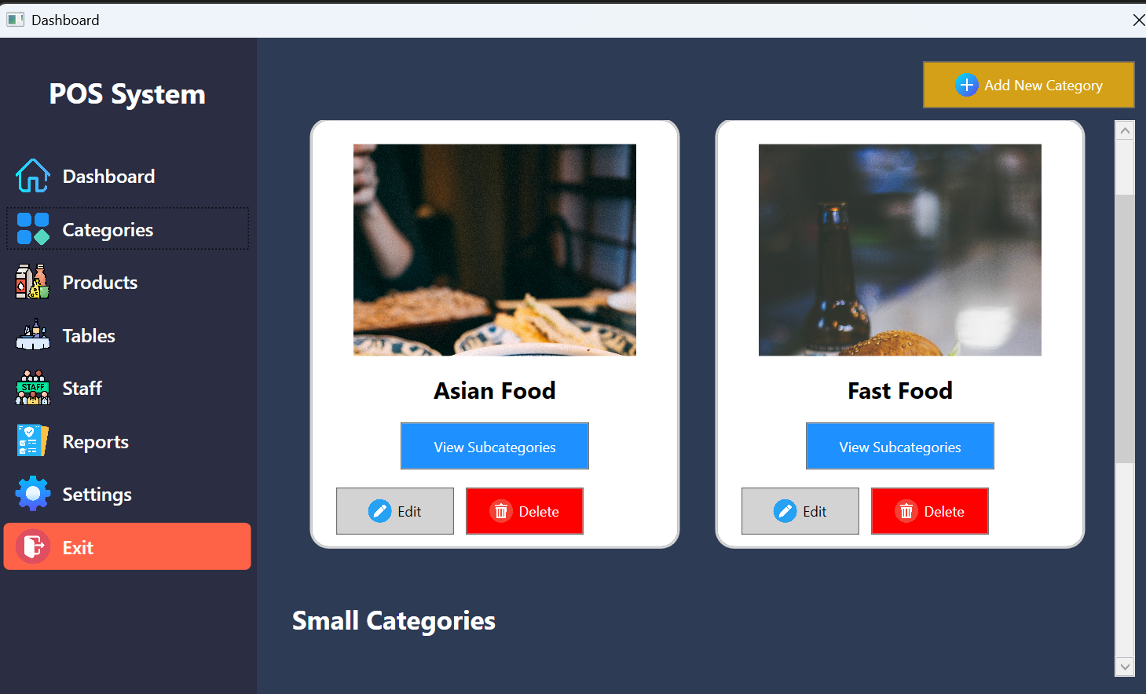
Category Page xaml

<Page x:Class="HotelDishManagement.CategoriesPage"
xmlns="http://schemas.microsoft.com/winfx/2006/xaml/presentation"
xmlns:x="http://schemas.microsoft.com/winfx/2006/xaml"
Title="CategoriesPage"
Background="#2E3B55">
<Grid Margin="20">
<Grid.RowDefinitions>
<RowDefinition Height="Auto" />
<RowDefinition Height="*" />
</Grid.RowDefinitions>

<!-- Add Category Button -->
<Button HorizontalAlignment="Right" Width="180" Height="40" Background="#D4A017" Foreground="White"
Click="AddCategory_Click" Margin="0,0,0,10">
<StackPanel Orientation="Horizontal" VerticalAlignment="Center">
<Image Source="Assets/add_icon.png" Width="20" Height="20" Margin="0,0,5,0" />
<TextBlock Text="Add New Category" VerticalAlignment="Center" />
</StackPanel>
</Button>

<!-- Scrollable Categories List -->
<ScrollViewer Grid.Row="1" VerticalScrollBarVisibility="Auto">
<StackPanel Margin="0,10,0,0">
<!-- Large Categories Section -->
<TextBlock Text="Large Categories" FontSize="22" FontWeight="Bold" Foreground="White" Margin="10,20,0,10" />
<UniformGrid Columns="2" x:Name="LargeCategoriesGrid" Margin="10" />

<!-- Small Categories Section -->
<TextBlock Text="Small Categories" FontSize="22" FontWeight="Bold" Foreground="White" Margin="10,20,0,10" />
<UniformGrid Columns="3" x:Name="SmallCategoriesGrid" Margin="10" />
</StackPanel>
</ScrollViewer>
</Grid>
</Page>
Backend

using System.Collections.Generic;
using System.Windows;
using System.Windows.Controls;

namespace HotelDishManagement
{
public partial class CategoriesPage : Page
{
private List<Category> largeCategories = new List<Category>
{
new Category { Name = "Asian Food", ImagePath = "Assets/asian_food.jpg", Subcategories = new List<SubCategory>
{
new SubCategory { Name = "Chinese Food", ImagePath = "Assets/chinese_food.jpg" },
new SubCategory { Name = "Thai Food", ImagePath = "Assets/thai_food.jpg" }
}
},
new Category { Name = "Fast Food", ImagePath = "Assets/fast_food.jpg", Subcategories = new List<SubCategory>
{
new SubCategory { Name = "Burgers", ImagePath = "Assets/burgers.jpg" },
new SubCategory { Name = "Pizza", ImagePath = "Assets/pizza.jpg" }
}
}
};

private List<Category> smallCategories = new List<Category>
{
new Category { Name = "Desserts", ImagePath = "Assets/desserts.jpg" },
new Category { Name = "Drinks", ImagePath = "Assets/drinks.jpg" },
new Category { Name = "Vegetarian", ImagePath = "Assets/vegetarian.jpg" }
};

public CategoriesPage()
{
InitializeComponent();
LoadCategories();
}

private void LoadCategories()
{
LargeCategoriesGrid.Children.Clear();
SmallCategoriesGrid.Children.Clear();

foreach (var category in largeCategories)
{
var categoryCard = CreateCategoryCard(category, true);
LargeCategoriesGrid.Children.Add(categoryCard);
}

foreach (var category in smallCategories)
{
var categoryCard = CreateCategoryCard(category, false);
SmallCategoriesGrid.Children.Add(categoryCard);
}
}

private Border CreateCategoryCard(Category category, bool isLargeCategory)
{
var border = new Border
{
Background = System.Windows.Media.Brushes.White,
BorderBrush = System.Windows.Media.Brushes.LightGray,
BorderThickness = new Thickness(2),
CornerRadius = new CornerRadius(15),
Margin = new Thickness(15),
Padding = new Thickness(10)
};

var stackPanel = new StackPanel();

// Add category image
var image = new Image
{
Source = new System.Windows.Media.Imaging.BitmapImage(new System.Uri(category.ImagePath, System.UriKind.Relative)),
Height = 180,
Width = 240,
Margin = new Thickness(0, 10, 0, 10),
Stretch = System.Windows.Media.Stretch.UniformToFill
};
stackPanel.Children.Add(image);

// Add category name
stackPanel.Children.Add(new TextBlock
{
Text = category.Name,
FontSize = 20,
FontWeight = FontWeights.Bold,
Margin = new Thickness(0, 5, 0, 5),
Foreground = System.Windows.Media.Brushes.Black,
TextAlignment = TextAlignment.Center
});

// Subcategories button for large categories
if (isLargeCategory && category.Subcategories != null)
{
var viewSubcategoriesButton = new Button
{
Content = "View Subcategories",
Background = System.Windows.Media.Brushes.DodgerBlue,
Foreground = System.Windows.Media.Brushes.White,
Height = 40,
Width = 160,
Margin = new Thickness(0, 10, 0, 0)
};
viewSubcategoriesButton.Click += (s, e) => ShowSubcategories(category);
stackPanel.Children.Add(viewSubcategoriesButton);
}

// Action buttons
var buttonsPanel = new StackPanel { Orientation = Orientation.Horizontal, Margin = new Thickness(0, 15, 0, 0) };

var editButton = new Button
{
Content = new StackPanel
{
Orientation = Orientation.Horizontal,
Children =
{
new Image { Source = new System.Windows.Media.Imaging.BitmapImage(new System.Uri("Assets/edit_icon.png", System.UriKind.Relative)), Width = 20, Height = 20, Margin = new Thickness(0,0,5,0) },
new TextBlock { Text = "Edit", VerticalAlignment = VerticalAlignment.Center }
}
},
Width = 100,
Height = 40,
Background = System.Windows.Media.Brushes.LightGray,
Foreground = System.Windows.Media.Brushes.Black,
Margin = new Thickness(10, 0, 10, 0)
};
editButton.Click += (s, e) => EditCategory(category);

var deleteButton = new Button
{
Content = new StackPanel
{
Orientation = Orientation.Horizontal,
Children =
{
new Image { Source = new System.Windows.Media.Imaging.BitmapImage(new System.Uri("Assets/delete_icon.png", System.UriKind.Relative)), Width = 20, Height = 20, Margin = new Thickness(0,0,5,0) },
new TextBlock { Text = "Delete", VerticalAlignment = VerticalAlignment.Center }
}
},
Width = 100,
Height = 40,
Background = System.Windows.Media.Brushes.Red,
Foreground = System.Windows.Media.Brushes.White
};
deleteButton.Click += (s, e) => DeleteCategory(category);

buttonsPanel.Children.Add(editButton);
buttonsPanel.Children.Add(deleteButton);

stackPanel.Children.Add(buttonsPanel);

border.Child = stackPanel;
return border;
}

private void ShowSubcategories(Category category)
{
var subcategoriesWindow = new SubcategoriesWindow(category.Subcategories);
subcategoriesWindow.ShowDialog();
}

private void EditCategory(Category category)
{
MessageBox.Show($"Edit {category.Name} functionality will be added later.");
}

private void DeleteCategory(Category category)
{
if (MessageBox.Show($"Are you sure you want to delete {category.Name}?", "Confirm Delete", MessageBoxButton.YesNo) == MessageBoxResult.Yes)
{
largeCategories.Remove(category);
smallCategories.Remove(category);
LoadCategories();
}
}

private void AddCategory_Click(object sender, RoutedEventArgs e)
{
var addCategoryWindow = new AddCategoryWindow();
if (addCategoryWindow.ShowDialog() == true)
{
smallCategories.Add(new Category
{
Name = addCategoryWindow.CategoryName,
ImagePath = addCategoryWindow.ImagePath
});
LoadCategories();
}
}
}

public class Category
{
public string Name { get; set; }
public string ImagePath { get; set; }
public List<SubCategory> Subcategories { get; set; }
}

public class SubCategory
{
public string Name { get; set; }
public string ImagePath { get; set; }
}
}

ADD Category window
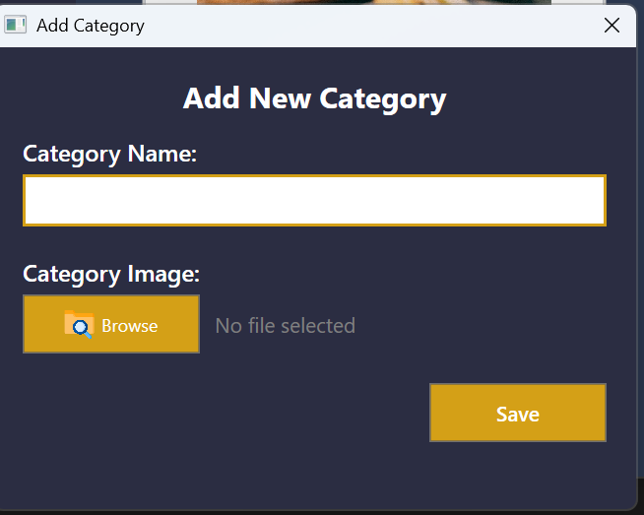
Xaml
<Window x:Class="HotelDishManagement.AddCategoryWindow"
xmlns="http://schemas.microsoft.com/winfx/2006/xaml/presentation"
xmlns:x="http://schemas.microsoft.com/winfx/2006/xaml"
Title="Add Category" Height="350" Width="450" WindowStartupLocation="CenterScreen" ResizeMode="NoResize"
Background="#2B2D42">
<Grid Margin="20">
<!-- Title -->
<TextBlock Text="Add New Category" FontSize="20" FontWeight="Bold" Foreground="White" HorizontalAlignment="Center" />

<!-- Form Fields -->
<StackPanel Margin="0,40,0,0">
<!-- Category Name -->
<TextBlock Text="Category Name:" FontSize="16" FontWeight="SemiBold" Foreground="White" Margin="0,0,0,5" />
<TextBox x:Name="CategoryNameBox" Height="35" FontSize="14" Padding="5" Margin="0,0,0,20"
Style="{StaticResource StylishTextBox}" />

<!-- Browse Image -->
<TextBlock Text="Category Image:" FontSize="16" FontWeight="SemiBold" Foreground="White" Margin="0,0,0,5" />
<StackPanel Orientation="Horizontal" VerticalAlignment="Center" Margin="0,0,0,20">
<Button x:Name="BrowseButton" Width="120" Height="40" Background="#D4A017" Foreground="White"
Click="BrowseImage_Click" Margin="0,0,10,0">
<StackPanel Orientation="Horizontal">
<Image Source="Assets/browse_icon.png" Width="20" Height="20" Margin="0,0,5,0" />
<TextBlock Text="Browse" VerticalAlignment="Center" />
</StackPanel>
</Button>
<TextBlock x:Name="ImagePathText" Text="No file selected" VerticalAlignment="Center"
Foreground="Gray" FontSize="14" />
</StackPanel>

<!-- Save Button -->
<Button x:Name="SaveButton" Content="Save" Width="120" Height="40" HorizontalAlignment="Right"
Background="#D4A017" Foreground="White" FontSize="14" FontWeight="SemiBold"
Click="SaveCategory_Click" />
</StackPanel>
</Grid>
</Window>

Backend

using Microsoft.Win32;
using System.Windows;

namespace HotelDishManagement
{
public partial class AddCategoryWindow : Window
{
public string CategoryName { get; private set; }
public string ImagePath { get; private set; }

public AddCategoryWindow()
{
InitializeComponent();
}

// Handle Browse Button Click
private void BrowseImage_Click(object sender, RoutedEventArgs e)
{
var dialog = new OpenFileDialog
{
Filter = "Image Files (*.jpg;*.png)|*.jpg;*.png",
Title = "Select a Category Image"
};

if (dialog.ShowDialog() == true)
{
ImagePath = dialog.FileName;
ImagePathText.Text = System.IO.Path.GetFileName(ImagePath); // Display file name
}
}

// Handle Save Button Click
private void SaveCategory_Click(object sender, RoutedEventArgs e)
{
if (string.IsNullOrWhiteSpace(CategoryNameBox.Text) || string.IsNullOrWhiteSpace(ImagePath))
{
MessageBox.Show("Please provide both a category name and an image.", "Validation Error", MessageBoxButton.OK, MessageBoxImage.Warning);
return;
}

CategoryName = CategoryNameBox.Text;
DialogResult = true; // Close window and return true
}
}
}

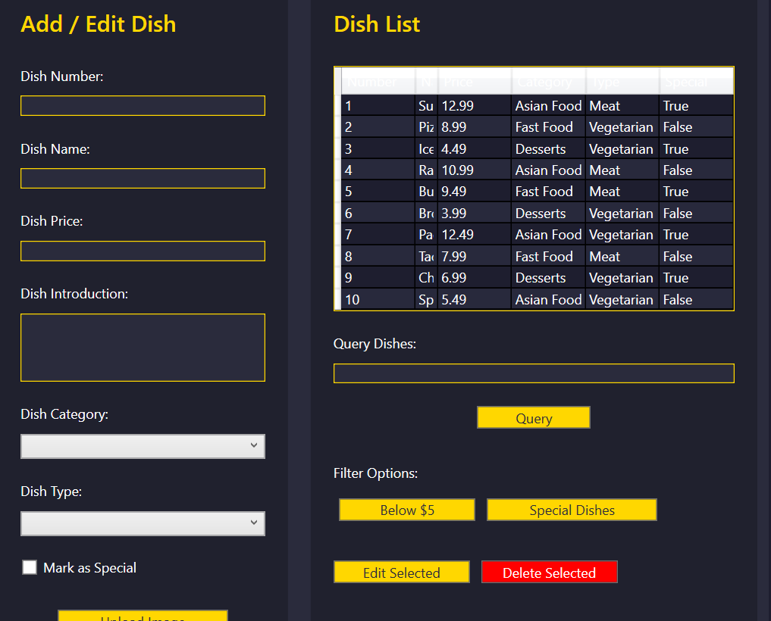
Dish window

<Page x:Class="HotelDishManagement.ProductsPage"
xmlns="http://schemas.microsoft.com/winfx/2006/xaml/presentation"
xmlns:x="http://schemas.microsoft.com/winfx/2006/xaml"
Title="ProductsPage">
<ScrollViewer VerticalScrollBarVisibility="Auto" HorizontalScrollBarVisibility="Disabled">
<Grid Background="#1E1E2F" Margin="20">
<Grid.RowDefinitions>
<RowDefinition Height="Auto" />
<RowDefinition Height="*" />
</Grid.RowDefinitions>

<!-- Header -->
<TextBlock Text="Product Management" FontSize="26" FontWeight="Bold" Foreground="White" Margin="0,0,0,20" />

<!-- Main Content Section -->
<Grid Grid.Row="1" Background="#2A2B3C" Margin="10">
<Grid.ColumnDefinitions>
<ColumnDefinition Width="2*" />
<ColumnDefinition Width="3*" />
</Grid.ColumnDefinitions>

<!-- Input Section -->
<Border Background="#20212E" CornerRadius="10" Margin="10">
<StackPanel Margin="20">
<TextBlock Text="Add / Edit Dish" FontSize="20" FontWeight="SemiBold" Foreground="#FFD700" Margin="0,0,0,15" />

<TextBlock Text="Dish Number:" Margin="0,10,0,5" Foreground="White" />
<TextBox x:Name="DishNumberTextBox" Margin="0,5,0,10" Background="#2A2B3C" Foreground="White" BorderBrush="#FFD700" BorderThickness="1" />

<TextBlock Text="Dish Name:" Margin="0,10,0,5" Foreground="White" />
<TextBox x:Name="DishNameTextBox" Margin="0,5,0,10" Background="#2A2B3C" Foreground="White" BorderBrush="#FFD700" BorderThickness="1" />

<TextBlock Text="Dish Price:" Margin="0,10,0,5" Foreground="White" />
<TextBox x:Name="DishPriceTextBox" Margin="0,5,0,10" Background="#2A2B3C" Foreground="White" BorderBrush="#FFD700" BorderThickness="1" />

<TextBlock Text="Dish Introduction:" Margin="0,10,0,5" Foreground="White" />
<TextBox x:Name="DishIntroductionTextBox" Margin="0,5,0,10" AcceptsReturn="True" TextWrapping="Wrap" Height="60"
Background="#2A2B3C" Foreground="White" BorderBrush="#FFD700" BorderThickness="1" />

<TextBlock Text="Dish Category:" Margin="0,10,0,5" Foreground="White" />
<ComboBox x:Name="DishCategoryComboBox" Margin="0,5,0,10" Background="#2A2B3C" Foreground="White" BorderBrush="#FFD700" BorderThickness="1">
<ComboBoxItem Content="Asian Food" />
<ComboBoxItem Content="Fast Food" />
<ComboBoxItem Content="Desserts" />
</ComboBox>

<TextBlock Text="Dish Type:" Margin="0,10,0,5" Foreground="White" />
<ComboBox x:Name="DishTypeComboBox" Margin="0,5,0,10" Background="#2A2B3C" Foreground="White" BorderBrush="#FFD700" BorderThickness="1">
<ComboBoxItem Content="Meat" />
<ComboBoxItem Content="Vegetarian" />
<ComboBoxItem Content="Vegan" />
</ComboBox>

<CheckBox x:Name="SpecialDishCheckBox" Content="Mark as Special" Foreground="White" Margin="0,10,0,10" />

<!-- Buttons -->
<Button Content="Upload Image" x:Name="UploadImageButton" Margin="0,20,0,10" Background="#FFD700" Foreground="#2A2B3C" Width="150" />
<Button Content="Add Dish" x:Name="AddDishButton" Margin="0,10,0,10" Background="#FFD700" Foreground="#2A2B3C" Width="150" />
</StackPanel>
</Border>

<!-- Display Section -->
<Border Grid.Column="1" Background="#20212E" CornerRadius="10" Margin="10">
<StackPanel Margin="20">
<TextBlock Text="Dish List" FontSize="20" FontWeight="SemiBold" Foreground="#FFD700" Margin="0,0,0,15" />

<!-- DataGrid for Dishes -->
<DataGrid x:Name="DishDataGrid" AutoGenerateColumns="False" CanUserAddRows="False" Margin="0,10,0,0" Background="#2A2B3C"
Foreground="White" BorderBrush="#FFD700" BorderThickness="1" RowBackground="#1E1E2F" AlternatingRowBackground="#28293C">
<DataGrid.Columns>
<DataGridTextColumn Header="Number" Binding="{Binding Number}" Width="100" />
<DataGridTextColumn Header="Name" Binding="{Binding Name}" Width="*" />
<DataGridTextColumn Header="Price" Binding="{Binding Price}" Width="100" />
<DataGridTextColumn Header="Category" Binding="{Binding Category}" Width="150" />
<DataGridTextColumn Header="Type" Binding="{Binding Type}" Width="100" />
<DataGridTextColumn Header="Special" Binding="{Binding IsSpecial}" Width="80" />
</DataGrid.Columns>
</DataGrid>

<!-- Query Section -->
<TextBlock Text="Query Dishes:" Margin="0,20,0,5" Foreground="White" />
<TextBox x:Name="QueryInputTextBox" Margin="0,5,0,10" Background="#2A2B3C" Foreground="White" BorderBrush="#FFD700" BorderThickness="1" />
<Button Content="Query" x:Name="QueryDishByInput" Margin="0,10,0,10" Background="#FFD700" Foreground="#2A2B3C" Width="100" Click="QueryDishByInput_Click" />

<!-- Filters -->
<TextBlock Text="Filter Options:" Margin="0,20,0,5" Foreground="White" />
<StackPanel Orientation="Horizontal" Margin="0,5,0,10">
<Button Content="Below $5" x:Name="FilterByPriceButton" Background="#FFD700" Foreground="#2A2B3C" Width="120" Margin="5" Click="FilterByPrice_Click" />
<Button Content="Special Dishes" x:Name="FilterBySpecialButton" Background="#FFD700" Foreground="#2A2B3C" Width="150" Margin="5" Click="FilterBySpecial_Click" />
</StackPanel>

<!-- Edit/Delete Buttons -->
<StackPanel Orientation="Horizontal" Margin="0,20,0,0">
<Button Content="Edit Selected" x:Name="EditDishButton" Margin="0,0,10,0" Background="#FFD700" Foreground="#2A2B3C" Width="120" />
<Button Content="Delete Selected" x:Name="DeleteDishButton" Background="Red" Foreground="White" Width="120" />
</StackPanel>
</StackPanel>
</Border>
</Grid>
</Grid>
</ScrollViewer>
</Page>
Backend
using System.Collections.ObjectModel;
using System.Linq;
using System.Windows;
using System.Windows.Controls;

namespace HotelDishManagement
{
public partial class ProductsPage : Page
{
public ObservableCollection<Dish> Dishes { get; set; } = new ObservableCollection<Dish>();

public ProductsPage()
{
InitializeComponent();
LoadDishes(); // Load hardcoded dishes
DishDataGrid.ItemsSource = Dishes; // Bind DataGrid to dishes
}

private void LoadDishes()
{
// Hardcoded list of 10 dishes
Dishes.Add(new Dish { Number = 1, Name = "Sushi", Price = 12.99, Introduction = "Fresh fish on rice", Category = "Asian Food", Type = "Meat", IsSpecial = true });
Dishes.Add(new Dish { Number = 2, Name = "Pizza", Price = 8.99, Introduction = "Classic cheese pizza", Category = "Fast Food", Type = "Vegetarian", IsSpecial = false });
Dishes.Add(new Dish { Number = 3, Name = "Ice Cream", Price = 4.49, Introduction = "Vanilla dessert", Category = "Desserts", Type = "Vegetarian", IsSpecial = true });
Dishes.Add(new Dish { Number = 4, Name = "Ramen", Price = 10.99, Introduction = "Japanese noodle soup", Category = "Asian Food", Type = "Meat", IsSpecial = false });
Dishes.Add(new Dish { Number = 5, Name = "Burger", Price = 9.49, Introduction = "Beef burger", Category = "Fast Food", Type = "Meat", IsSpecial = true });
Dishes.Add(new Dish { Number = 6, Name = "Brownie", Price = 3.99, Introduction = "Chocolate dessert", Category = "Desserts", Type = "Vegetarian", IsSpecial = false });
Dishes.Add(new Dish { Number = 7, Name = "Pad Thai", Price = 12.49, Introduction = "Stir-fried noodles with peanuts", Category = "Asian Food", Type = "Vegetarian", IsSpecial = true });
Dishes.Add(new Dish { Number = 8, Name = "Tacos", Price = 7.99, Introduction = "Mexican-style tacos", Category = "Fast Food", Type = "Meat", IsSpecial = false });
Dishes.Add(new Dish { Number = 9, Name = "Cheesecake", Price = 6.99, Introduction = "Rich and creamy cheesecake", Category = "Desserts", Type = "Vegetarian", IsSpecial = true });
Dishes.Add(new Dish { Number = 10, Name = "Spring Rolls", Price = 5.49, Introduction = "Crispy vegetarian rolls", Category = "Asian Food", Type = "Vegetarian", IsSpecial = false });
}

private void AddDishButton_Click(object sender, RoutedEventArgs e)
{
var newDish = new Dish
{
Number = int.Parse(DishNumberTextBox.Text),
Name = DishNameTextBox.Text,
Price = double.Parse(DishPriceTextBox.Text),
Introduction = DishIntroductionTextBox.Text,
Category = ((ComboBoxItem)DishCategoryComboBox.SelectedItem).Content.ToString(),
Type = ((ComboBoxItem)DishTypeComboBox.SelectedItem).Content.ToString(),
IsSpecial = SpecialDishCheckBox.IsChecked == true
};

Dishes.Add(newDish);
ClearInputFields();
}

private void EditDishButton_Click(object sender, RoutedEventArgs e)
{
if (DishDataGrid.SelectedItem is Dish selectedDish)
{
selectedDish.Name = DishNameTextBox.Text;
selectedDish.Price = double.Parse(DishPriceTextBox.Text);
selectedDish.Introduction = DishIntroductionTextBox.Text;
selectedDish.Category = ((ComboBoxItem)DishCategoryComboBox.SelectedItem).Content.ToString();
selectedDish.Type = ((ComboBoxItem)DishTypeComboBox.SelectedItem).Content.ToString();
selectedDish.IsSpecial = SpecialDishCheckBox.IsChecked == true;

DishDataGrid.Items.Refresh();
ClearInputFields();
}
}

private void DeleteDishButton_Click(object sender, RoutedEventArgs e)
{
if (DishDataGrid.SelectedItem is Dish selectedDish)
{
Dishes.Remove(selectedDish);
}
}

private void QueryDishByInput_Click(object sender, RoutedEventArgs e)
{
string query = QueryInputTextBox.Text.ToLower();

var filteredDishes = Dishes.Where(d =>
d.Number.ToString().Contains(query) ||
d.Name.ToLower().Contains(query) ||
d.Introduction.ToLower().Contains(query) ||
d.Category.ToLower().Contains(query) ||
d.Price.ToString("F2").Contains(query)).ToList();

if (filteredDishes.Any())
{
DishDataGrid.ItemsSource = filteredDishes;
}
else
{
MessageBox.Show("No matching dishes found!", "Query Results", MessageBoxButton.OK, MessageBoxImage.Information);
DishDataGrid.ItemsSource = Dishes; // Reset to all dishes
}
}

private void FilterByPrice_Click(object sender, RoutedEventArgs e)
{
var filteredDishes = Dishes.Where(d => d.Price < 5).ToList();

if (filteredDishes.Any())
{
DishDataGrid.ItemsSource = filteredDishes;
}
else
{
MessageBox.Show("No dishes under $5 found!", "Filter Results", MessageBoxButton.OK, MessageBoxImage.Information);
DishDataGrid.ItemsSource = Dishes; // Reset to all dishes
}
}

private void FilterBySpecial_Click(object sender, RoutedEventArgs e)
{
var filteredDishes = Dishes.Where(d => d.IsSpecial).ToList();

if (filteredDishes.Any())
{
DishDataGrid.ItemsSource = filteredDishes;
}
else
{
MessageBox.Show("No special dishes found!", "Filter Results", MessageBoxButton.OK, MessageBoxImage.Information);
DishDataGrid.ItemsSource = Dishes; // Reset to all dishes
}
}

private void ClearInputFields()
{
DishNumberTextBox.Clear();
DishNameTextBox.Clear();
DishPriceTextBox.Clear();
DishIntroductionTextBox.Clear();
DishCategoryComboBox.SelectedIndex = -1;
DishTypeComboBox.SelectedIndex = -1;
SpecialDishCheckBox.IsChecked = false;
}
}

public class Dish
{
public int Number { get; set; }
public string Name { get; set; }
public double Price { get; set; }
public string Introduction { get; set; }
public string Category { get; set; }
public string Type { get; set; }
public bool IsSpecial { get; set; }
}
}
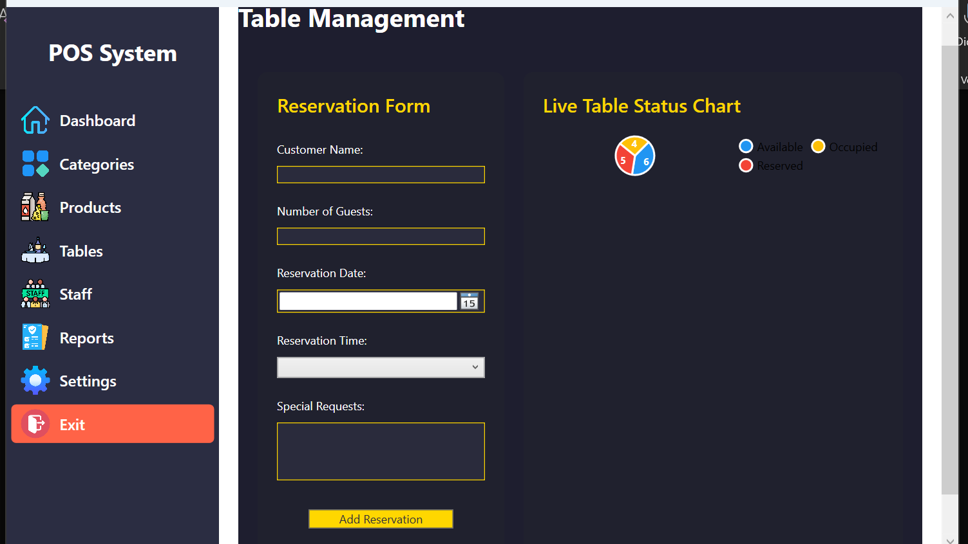
Table window
<Page x:Class="HotelDishManagement.TablesPage"
xmlns="http://schemas.microsoft.com/winfx/2006/xaml/presentation"
xmlns:x="http://schemas.microsoft.com/winfx/2006/xaml"
xmlns:lvc="clr-namespace:LiveCharts.Wpf;assembly=LiveCharts.Wpf"
Title="TablesPage">
<ScrollViewer VerticalScrollBarVisibility="Auto" HorizontalScrollBarVisibility="Disabled">
<Grid Background="#1E1E2F" Margin="20">
<Grid.RowDefinitions>
<RowDefinition Height="Auto" />
<RowDefinition Height="*" />
</Grid.RowDefinitions>

<!-- Header -->
<TextBlock Text="Table Management" FontSize="26" FontWeight="Bold" Foreground="White" Margin="0,0,0,20" />

<!-- Main Content -->
<Grid Grid.Row="1" Margin="10">
<Grid.ColumnDefinitions>
<ColumnDefinition Width="2*" />
<ColumnDefinition Width="3*" />
</Grid.ColumnDefinitions>

<!-- Reservation Form -->
<Border Background="#20212E" Margin="10" CornerRadius="10">
<StackPanel Margin="20">
<TextBlock Text="Reservation Form" FontSize="20" FontWeight="SemiBold" Foreground="#FFD700" Margin="0,0,0,15" />

<TextBlock Text="Customer Name:" Margin="0,10,0,5" Foreground="White" />
<TextBox x:Name="CustomerNameTextBox" Margin="0,5,0,10" Background="#2A2B3C" Foreground="White" BorderBrush="#FFD700" BorderThickness="1" />

<TextBlock Text="Number of Guests:" Margin="0,10,0,5" Foreground="White" />
<TextBox x:Name="NumberOfGuestsTextBox" Margin="0,5,0,10" Background="#2A2B3C" Foreground="White" BorderBrush="#FFD700" BorderThickness="1" />

<TextBlock Text="Reservation Date:" Margin="0,10,0,5" Foreground="White" />
<DatePicker x:Name="ReservationDatePicker" Margin="0,5,0,10" Background="#2A2B3C" Foreground="White" BorderBrush="#FFD700" />

<TextBlock Text="Reservation Time:" Margin="0,10,0,5" Foreground="White" />
<ComboBox x:Name="ReservationTimeComboBox" Margin="0,5,0,10" Background="#2A2B3C" Foreground="White" BorderBrush="#FFD700" BorderThickness="1">
<ComboBoxItem Content="12:00 PM" />
<ComboBoxItem Content="12:30 PM" />
<ComboBoxItem Content="1:00 PM" />
<ComboBoxItem Content="1:30 PM" />
</ComboBox>

<TextBlock Text="Special Requests:" Margin="0,10,0,5" Foreground="White" />
<TextBox x:Name="SpecialRequestsTextBox" Margin="0,5,0,10" AcceptsReturn="True" TextWrapping="Wrap" Height="60"
Background="#2A2B3C" Foreground="White" BorderBrush="#FFD700" BorderThickness="1" />

<Button Content="Add Reservation" x:Name="AddReservationButton" Margin="0,20,0,10" Background="#FFD700" Foreground="#2A2B3C" Width="150" Click="AddReservationButton_Click" />
</StackPanel>
</Border>

<!-- Table Overview -->
<Border Grid.Column="1" Background="#20212E" Margin="10" CornerRadius="10">
<StackPanel Margin="20">
<TextBlock Text="Table Overview" FontSize="20" FontWeight="SemiBold" Foreground="#FFD700" Margin="0,0,0,15" />

<StackPanel Orientation="Horizontal" Margin="0,10,0,20">
<Button Content="Available" x:Name="FilterAvailableButton" Background="#FFD700" Foreground="#2A2B3C" Width="100" Margin="5" Click="FilterAvailable_Click" />
<Button Content="Reserved" x:Name="FilterReservedButton" Background="#FFD700" Foreground="#2A2B3C" Width="100" Margin="5" Click="FilterReserved_Click" />
<Button Content="Occupied" x:Name="FilterOccupiedButton" Background="#FFD700" Foreground="#2A2B3C" Width="100" Margin="5" Click="FilterOccupied_Click" />
</StackPanel>

<ListView x:Name="TableListView" Background="#2A2B3C" Foreground="White" BorderBrush="#FFD700" BorderThickness="1" Height="200">
<ListView.ItemTemplate>
<DataTemplate>
<StackPanel Orientation="Horizontal" Margin="5">
<TextBlock Text="{Binding TableNumber}" FontWeight="Bold" Foreground="White" Margin="5,0" />
<TextBlock Text=": " Foreground="White" />
<TextBlock Text="{Binding Status}" Foreground="#FFD700" Margin="5,0" />
</StackPanel>
</DataTemplate>
</ListView.ItemTemplate>
</ListView>
</StackPanel>
</Border>

<!-- Live Chart -->
<Border Grid.Column="1" Background="#20212E" Margin="10" CornerRadius="10">
<StackPanel Margin="20">
<TextBlock Text="Live Table Status Chart" FontSize="20" FontWeight="SemiBold" Foreground="#FFD700" Margin="0,0,0,15" />
<lvc:PieChart x:Name="TableStatusChart" LegendLocation="Right" />
</StackPanel>
</Border>
</Grid>
</Grid>
</ScrollViewer>
</Page>
Backend
using System.Collections.ObjectModel;
using System.Linq;
using System.Windows;
using System.Windows.Controls;
using LiveCharts;
using LiveCharts.Wpf;

namespace HotelDishManagement
{
public partial class TablesPage : Page
{
public ObservableCollection<Table> Tables { get; set; } = new ObservableCollection<Table>();
public ChartValues<int> Available { get; set; } = new ChartValues<int>();
public ChartValues<int> Reserved { get; set; } = new ChartValues<int>();
public ChartValues<int> Occupied { get; set; } = new ChartValues<int>();

public TablesPage()
{
InitializeComponent();

// Sample data
Tables.Add(new Table { TableNumber = 1, Status = "Available" });
Tables.Add(new Table { TableNumber = 2, Status = "Reserved" });
Tables.Add(new Table { TableNumber = 3, Status = "Occupied" });
Tables.Add(new Table { TableNumber = 4, Status = "Available" });
Tables.Add(new Table { TableNumber = 5, Status = "Reserved" });
Tables.Add(new Table { TableNumber = 6, Status = "Occupied" });
Tables.Add(new Table { TableNumber = 7, Status = "Available" });
Tables.Add(new Table { TableNumber = 8, Status = "Occupied" });
Tables.Add(new Table { TableNumber = 9, Status = "Reserved" });
Tables.Add(new Table { TableNumber = 10, Status = "Available" });
Tables.Add(new Table { TableNumber = 11, Status = "Available" });
Tables.Add(new Table { TableNumber = 12, Status = "Reserved" });
Tables.Add(new Table { TableNumber = 13, Status = "Occupied" });
Tables.Add(new Table { TableNumber = 14, Status = "Reserved" });
Tables.Add(new Table { TableNumber = 15, Status = "Available" });

TableListView.ItemsSource = Tables;
UpdateChart();
}

private void UpdateChart()
{
var availableCount = Tables.Count(t => t.Status == "Available");
var reservedCount = Tables.Count(t => t.Status == "Reserved");
var occupiedCount = Tables.Count(t => t.Status == "Occupied");

TableStatusChart.Series = new SeriesCollection
{
new PieSeries { Title = "Available", Values = new ChartValues<int> { availableCount }, DataLabels = true },
new PieSeries { Title = "Reserved", Values = new ChartValues<int> { reservedCount }, DataLabels = true },
new PieSeries { Title = "Occupied", Values = new ChartValues<int> { occupiedCount }, DataLabels = true }
};
}

private void AddReservationButton_Click(object sender, RoutedEventArgs e)
{
if (int.TryParse(NumberOfGuestsTextBox.Text, out int guests) && !string.IsNullOrWhiteSpace(CustomerNameTextBox.Text))
{
Tables.Add(new Table
{
TableNumber = Tables.Count + 1,
Status = "Reserved"
});

TableListView.Items.Refresh();
UpdateChart();
MessageBox.Show("Reservation Added Successfully!");
}
else
{
MessageBox.Show("Please fill all required fields.");
}
}

private void FilterAvailable_Click(object sender, RoutedEventArgs e)
{
TableListView.ItemsSource = Tables.Where(t => t.Status == "Available");
}

private void FilterReserved_Click(object sender, RoutedEventArgs e)
{
TableListView.ItemsSource = Tables.Where(t => t.Status == "Reserved");
}

private void FilterOccupied_Click(object sender, RoutedEventArgs e)
{
TableListView.ItemsSource = Tables.Where(t => t.Status == "Occupied");
}
}

public class Table
{
public int TableNumber { get; set; }
public string Status { get; set; }
}
}

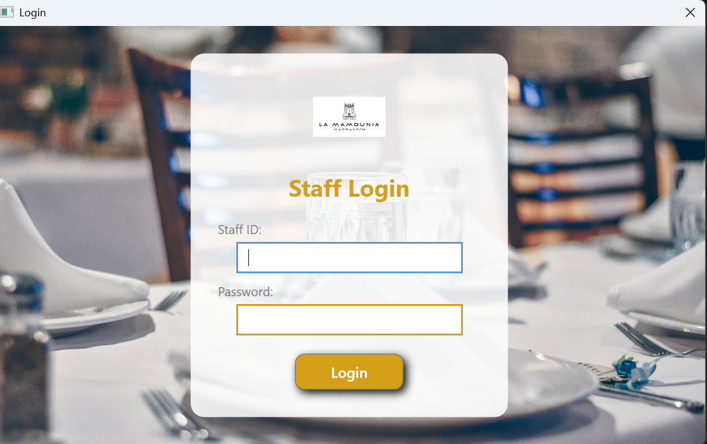
Login window
<Window x:Class="HotelDishManagement.MainWindow"
xmlns="http://schemas.microsoft.com/winfx/2006/xaml/presentation"
xmlns:x="http://schemas.microsoft.com/winfx/2006/xaml"
Title="Login" Height="500" Width="800" WindowStartupLocation="CenterScreen" ResizeMode="NoResize">
<Grid>
<!-- Background Image -->
<Grid.Background>
<ImageBrush ImageSource="hotel_restaurant.jpg" Stretch="UniformToFill" />
</Grid.Background>

<!-- Centered Login Panel -->
<Border Background="#DDFFFFFF" CornerRadius="15" Padding="30" Width="350" VerticalAlignment="Center" HorizontalAlignment="Center">
<StackPanel>
<!-- Hotel Logo -->
<Image Source="hotel_logo.jpg" Height="80" Width="80" HorizontalAlignment="Center" Margin="0,0,0,20" />

<!-- Title -->
<TextBlock Text="Staff Login" FontSize="26" FontWeight="Bold" Foreground="#D4A017" HorizontalAlignment="Center" Margin="0,0,0,20"/>

<!-- Staff ID -->
<TextBlock Text="Staff ID:" FontSize="14" Foreground="Gray" Margin="0,0,0,5"/>
<TextBox x:Name="txtStaffID" Width="250" Height="35" FontSize="14" Margin="0,0,0,10"
Style="{StaticResource StylishTextBox}" />

<!-- Password -->
<TextBlock Text="Password:" FontSize="14" Foreground="Gray" Margin="0,0,0,5"/>
<PasswordBox x:Name="txtPassword" Width="250" Height="35" FontSize="14" Margin="0,0,0,20"
Style="{StaticResource StylishPasswordBox}" />

<!-- Login Button -->
<Button Content="Login" Width="120" Height="40" FontSize="16" Foreground="White" Background="#D4A017"
HorizontalAlignment="Center" Padding="5"
Style="{StaticResource StylishButton}" Click="LoginButton_Click"/>
</StackPanel>
</Border>
</Grid>
</Window>

using System.Collections.Generic;
using System.Windows;

namespace HotelDishManagement
{
public partial class MainWindow : Window
{
// Hardcoded Staff Credentials (to be replaced with database later)
private readonly Dictionary<string, string> staffCredentials = new Dictionary<string, string>
{
{ "admin", "12345" },
{ "staff1", "password1" },
{ "staff2", "securepass" }
};

public MainWindow()
{
InitializeComponent();
DatabaseInitializer.InitializeDatabase();

}

private void LoginButton_Click(object sender, RoutedEventArgs e)
{
string staffID = txtStaffID.Text;
string password = txtPassword.Password;

// Validate credentials
if (staffCredentials.ContainsKey(staffID) && staffCredentials[staffID] == password)
{
// Open Dashboard if login is successful
Dashboard dashboard = new Dashboard();
dashboard.Show();
this.Close(); // Close the login window
}
else
{
MessageBox.Show("Invalid Staff ID or Password", "Login Failed", MessageBoxButton.OK, MessageBoxImage.Warning);
}
}
}
}
APP

<Application x:Class="HotelDishManagement.App"
xmlns="http://schemas.microsoft.com/winfx/2006/xaml/presentation"
xmlns:x="http://schemas.microsoft.com/winfx/2006/xaml"
xmlns:local="clr-namespace:HotelDishManagement"
StartupUri="MainWindow.xaml">
<Application.Resources>
<!-- Drop Shadow Effect -->
<DropShadowEffect x:Key="ShadowEffect" BlurRadius="15" ShadowDepth="5" Color="Black" />
<Style x:Key="StylishTextBox" TargetType="TextBox">
<Setter Property="Padding" Value="10,5,10,5" />
<Setter Property="FontSize" Value="16" />
<Setter Property="BorderBrush" Value="#D4A017" />
<Setter Property="BorderThickness" Value="2" />
<Setter Property="FontFamily" Value="Segoe UI" />
<Setter Property="Background" Value="White" />
<Setter Property="Foreground" Value="Black" />
<Setter Property="VerticalContentAlignment" Value="Center" />
</Style>

<!-- Stylish PasswordBox -->
<Style x:Key="StylishPasswordBox" TargetType="PasswordBox">
<Setter Property="Padding" Value="10,5,10,5" />
<Setter Property="FontSize" Value="16" />
<Setter Property="BorderBrush" Value="#D4A017" />
<Setter Property="BorderThickness" Value="2" />
<Setter Property="FontFamily" Value="Segoe UI" />
<Setter Property="Background" Value="White" />
<Setter Property="Foreground" Value="Black" />
<Setter Property="VerticalContentAlignment" Value="Center" />
</Style>

<!-- Stylish Button with Rounded Corners -->
<Style x:Key="StylishButton" TargetType="Button">
<Setter Property="FontFamily" Value="Segoe UI" />
<Setter Property="FontWeight" Value="SemiBold" />
<Setter Property="Padding" Value="10,5" />
<Setter Property="Background" Value="#D4A017" />
<Setter Property="Foreground" Value="White" />
<Setter Property="Effect" Value="{StaticResource ShadowEffect}" />
<Setter Property="Template">
<Setter.Value>
<ControlTemplate TargetType="Button">
<Border CornerRadius="10" Background="{TemplateBinding Background}" BorderBrush="{TemplateBinding BorderBrush}" BorderThickness="{TemplateBinding BorderThickness}">
<ContentPresenter HorizontalAlignment="Center" VerticalAlignment="Center" />
</Border>
</ControlTemplate>
</Setter.Value>
</Setter>
</Style>
<Style x:Key="SidebarButton" TargetType="Button">
<Setter Property="FontFamily" Value="Segoe UI" />
<Setter Property="FontSize" Value="16" />
<Setter Property="FontWeight" Value="SemiBold" />
<Setter Property="Foreground" Value="White" />
<Setter Property="Background" Value="#2B2D42" />
<Setter Property="Padding" Value="10" />
<Setter Property="Margin" Value="5,5,5,0" />
<Setter Property="HorizontalContentAlignment" Value="Left" />
<Setter Property="Cursor" Value="Hand" />
<Setter Property="Template">
<Setter.Value>
<ControlTemplate TargetType="Button">
<Grid>
<Border Background="{TemplateBinding Background}" CornerRadius="5">
<Grid>
<!-- Hover effect -->
<Border x:Name="HoverOverlay" Opacity="0">
<Border.Background>
<LinearGradientBrush StartPoint="0,0" EndPoint="1,1">
<GradientStop Color="#394452" Offset="0.0" />
<GradientStop Color="#2B2D42" Offset="1.0" />
</LinearGradientBrush>
</Border.Background>
</Border>
<StackPanel Orientation="Horizontal" VerticalAlignment="Center" Margin="10,5,0,5">
<!-- Icon -->
<Image Source="{Binding RelativeSource={RelativeSource TemplatedParent}, Path=Tag}" Width="30" Height="30" Margin="0,0,10,0" />
<!-- Text -->
<TextBlock Text="{TemplateBinding Content}" VerticalAlignment="Center" Foreground="White" />
</StackPanel>
</Grid>
</Border>
</Grid>
<ControlTemplate.Triggers>
<!-- Mouse Over Trigger -->
<Trigger Property="IsMouseOver" Value="True">
<Setter TargetName="HoverOverlay" Property="Opacity" Value="1" />
</Trigger>
</ControlTemplate.Triggers>
</ControlTemplate>
</Setter.Value>
</Setter>
</Style>
<BitmapImage x:Key="IconDashboard" UriSource="Assets/dashboard.png" />
<BitmapImage x:Key="IconCategories" UriSource="Assets/categories.png" />
<BitmapImage x:Key="IconProducts" UriSource="Assets/products.png" />
<BitmapImage x:Key="IconTables" UriSource="Assets/tables.png" />
<BitmapImage x:Key="IconStaff" UriSource="Assets/staff.png" />
<BitmapImage x:Key="IconReports" UriSource="Assets/reports.png" />
<BitmapImage x:Key="IconSettings" UriSource="Assets/settings.png" />
<BitmapImage x:Key="IconExit" UriSource="Assets/exit.png" />

<!-- Exit Button Style -->
<Style x:Key="SidebarExitButton" TargetType="Button" BasedOn="{StaticResource SidebarButton}">
<Setter Property="Background" Value="#FF6347" />
<!-- Red for exit button -->
</Style>
</Application.Resources>

</Application>

Source Code: HotelDishManagement
App : New folder

Course design report score sheet
Sequence number | Rating items | Maximum score | Score
a | Study attitude for the course design is serious, and the course design report meets the template requirements; | 10
b | The course design report content is comprehensive and the course design process is complete; | 30
c | Learning contents are deeply analyzed in the course design with unique insights and strong practical ability; | 30
d | Course design tasks are completed well； | 20
e | The course design report is well illustrated and well typed. | 10
 |  | Total score

